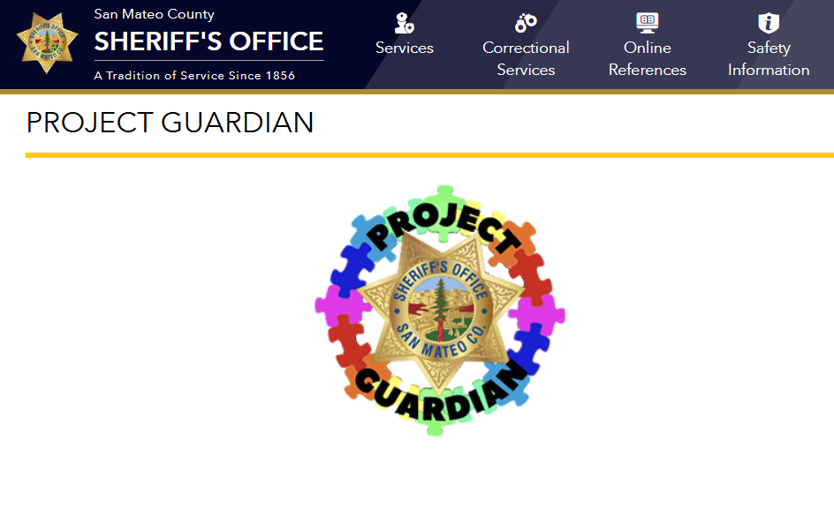

- Versión en Español haz clic aquí.
Sheriff Christina Corpus is excited to announce the commencement of our Project Guardian program. Project Guardian is a voluntary program where individuals, families, or caregivers can register those who might be vulnerable, at-risk, or have special needs with the San Mateo County Sheriff’s Office. Though primarily designed to provide awareness and tools for deputies interacting with individuals with autism, we believe by broadening the scope, we can also help those with a variety of needs.
Project Guardian participants are able to provide comprehensive information including communication preferences, triggers, special concerns, and calming strategies along with a photograph and emergency contact information. The Sheriff’s Office will build and maintain this confidential information in our Project Guardian registry. Members of our office can access this secure information prior to or during a contact so they are better equipped for interactions, can de-escalate situations, and are able to earn the trust of those who might require or prefer different styles and approaches.
If you or someone you know would benefit from this service, please fill out the Project Guardian registration form below. Please note that once a registration form is submitted, the system will send an automated email back to the email address entered. Once your Project Guardian registration information has been added to our system, we will send you a letter confirming your participation as well as Project Guardian stickers for your vehicle and/or residence.
Although anyone who resides in San Mateo County may register with us, please note that at this time, only the Sheriff’s Office will have access to your Project Guardian registry information. Therefore, if a contact takes place with an agency outside our jurisdiction, this information may not be available to them. The Sheriff’s Office jurisdiction includes all unincorporated areas within San Mateo County, as well as Woodside, Portola Valley, San Carlos, Half Moon Bay, and Millbrae.
If you have any questions about the Project Guardian program, please contact Sheriffs_ProjectGuardian@smcgov.org
Please fill out all applicable information. All information is voluntary and confidential.
